DIGITALIZATION IN TRAFFIC SECTOR

¹Mr. Siddaramaiah A G, ²Mr. Rakesh D P, ³Mr. Vijayakumar R, ⁴Mr. Sridhara P S, ⁵Mr. Gururaj S P
^{1,2,3,4}Students, ⁵Assistant Professor
Department of Computer science and Engineering
Siddaganga Institute of Technology, Tumakuru, India

Abstract- At present we supposed to provide documents in hardcopy to officers for verification. Public have to wait if there is crowd, even though if they have proper documents. Suppose if they failed to submit the proper documents they will be fined. In case of emergency if public deny to officer approach their vehicle will be seized. Officers may case a file against public if they failed to submit documents on time. Some of them are escaping by submission fake documents (Ex., Insurance, Driver License, Emission Test, Vehicle permits etc.,) which are custom created. Current systems are not enough to reduce signal jump and no-parking issues.

Keywords: Raspberry Pi, RFID Reader and Tag, Driving License, Insurance

I.INTRODUCTION

In the past decades, with the increasing of vehicles, traffic management is facing an accumulation of ever-growing pressure. Present system cannot provide intelligent to track vehicles which can jumping the red light or vehicles parking in no-parking place, which should do manually where lot of manual work involved. Many people have developed automated systems to overcome these major issues. This proposed system helps to avoid all above stated problems. While checking the documents of vehicle, officers only just to scan the RFID tags. So that all documents will be display by using the data stored in tags, which is already verified by superior officer stored in Database. So that both public and officers can save their time and energy. No need to carry their documents, just to update their vehicle Information at regular interval of time. (Ex., Insurance, Emission Test, Vehicle permits etc.,) RFID reader will be installed at the checking premises and RFID tag will be attached to the front part of the vehicle.

II. RELATED WORKS

Before the IOT technology we cannot do the machine controlling over the internet. But the IOT provides the security and safety to the user and the system. An efficient Automatic Attendance. International Journal on Computer Science and Engineering (IJCSE).[1].On the basis of finger print verification technique the automatic attendance system was proposed. The proposed automatic attendance system results either true or false with respect to the logical result of previous one to one verification of person’s authenticity. Main concept behind Radio Frequency Identification (RFID) based attendance system is to take the attendance of students or employees in any college or university or company. Student Wolf pack Club Tracking System. North Carolina State University in 2003.[2].The Proposed student wolf pack club tracking system to make it simple and accelerate the process of student wolf pack club ticket distribution for athletic event. Our proposition emphasizes a reliable, simple and effective model in of cost for face-face classrooms attendance management with additional short message services to parents as daily summary uses existing student ID card chip as the passive tag. RFID based toll collection system. IRACST- International Journal of Computer Science and Information Technology & Security (IJCSITS).[3].This model discuss about RFID technology for automating the process of toll booth system. RFID stands for Radio Frequency Identification .The components of the RFID System basically include RFID transmitter, a RFID receiver and some processing machine. RFID Based Biometric Electronic Voting Machine. International Journal of Scientific Research and Management Studies.[4].The incensed objective of this paper is to develop and design a RFID based electronic voting machine and to get rid of problems with wired techniques fingerprint scanner is used.
Toll collection system. International Journal of Computer Science and Information Technology & Security (IJCSITS). [5]. The design is based on the microcontroller (ATmega2560), RS232 cable which is used for interfacing between microcontroller and the fingerprint module, Liquid Crystal Display (16X2) for displaying the instructions and voter information, fingerprint module for scanning voter’s fingerprint before voting, RFID reader, RFID tag, Buzzer alarm. If Indian government adopts biometric voting system for voting purpose we can easily avoid rigging in election.

III. SYSTEM DESIGN AND ARCHITECTURE

In this paper we proposed four major models are
- No Parking
- Signal Jump
- Driving License verification
- Vehicle Document verification
Pre requirements:
All vehicles are embedded with RFID tag and people are registered with proper vehicle like registered number, RFID tag number, owner name, owner address, phone number, date of registration, insurance issue date and expiry date and driver details such as name, date of birth, address, phone number, issue date and expiry date in our portal. Every DL holder must register in our website along with the unique id with respect to finger print.
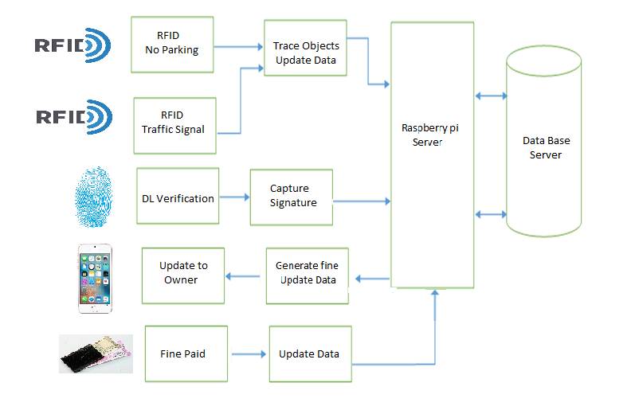
Fig-1: High-level Architecture.

No Parking: No- parking board is embedded with RFID reader which senses the signal about 5-10 meters in ideal state. When a vehicle parked in No- parking area, RFID reader senses the data from RFID tag of vehicle which parking in its area and timer starts and it started to sense the signal continuously. By that time RFID reader sent sensed data to server. In server it fetches the entry in the database and retrieves vehicle and owner details. When timer reaches particular time like 5 minutes, signal sent to server then a no parking complaint is registered in server and updated with both customers by message and in database as well.

Signal Jump: We embedded the RFID reader 5-8 meters away from zebra crossing. When the signal is red state and if any vehicle jumps the signal, RFID readers fetches the RFID tags details from that vehicle and send the same to the server. A server registers the signal jump complaint along with date, time and area in database and updates it with customer by message. If the signal other than red color then RFID ignore the tag signal from vehicles.

Driving License: Nowadays, people are facing lots of problems related in DL verification. Conventional methods are not able to solve the issues. So, we decided to create unique id for every person with the help of bio metric tool. Finger print sensor is used by the officer for checking. So people can use their finger instead of hard copy. From the help of this module People can move anywhere without hardcopy of DL if this method comes into existence.

Vehicle document verification: This is similar to driving license the only difference is RFID is used instead of bio metric tool. Each vehicle is provided with RFID tag during the registration process. So we can fetch the details for checking process with the help of RFID tag and RFID reader.

IV. WORK FLOW
The Work flow contains the flow of process in our system. We have divided the entire process into four sub process. Vehicle verification, complaint against vehicles which violates signal rules, DL verification of a rider and No parking issue.

Except DL verification all other modules works with the help of unique RFID number. For DL verification we planned to go for fingerprint which will be generated, uniquely for every user from the help of biometric tool. Flowchart is a graphical representation of the steps in a process for the better understanding of the process.

Algorithm for No parking
Step 1: Start
Step 2: Scan the RFID tag using reader.
Step 3: Get User Id.
Step 4: If Vehicle parked _time < 5 Min. Go to step 6.
Step 5: Register a complaint and put fine.
Step 6: Start from Step 1.
Step 7: End.
Algorithm for Signal Jump process
Step 1 : Start
Step 2 : Scan the RFID tag using reader.
Step 3 : If Traffic Signal is Not Red. Go to Step 5
Step 4 : Register a complaint notify the fine Amount to the Owner through SMS.
Step 5 : Start from Step 1.
Step 6 : End.

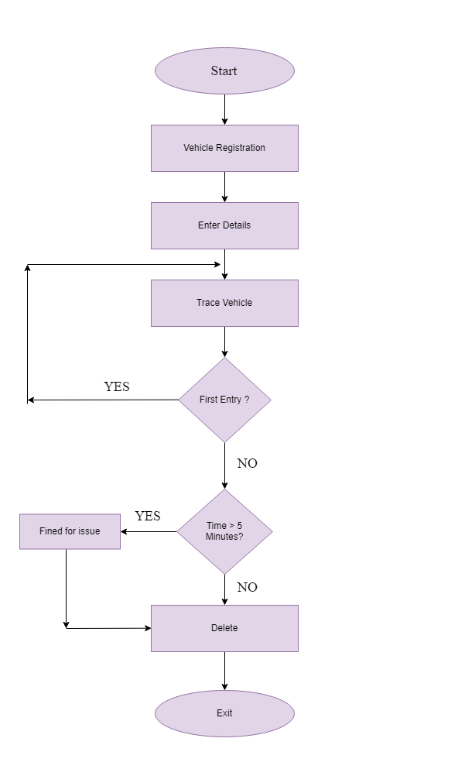
Fig-3: Graphical representation of flow of steps in Signal Jump process.

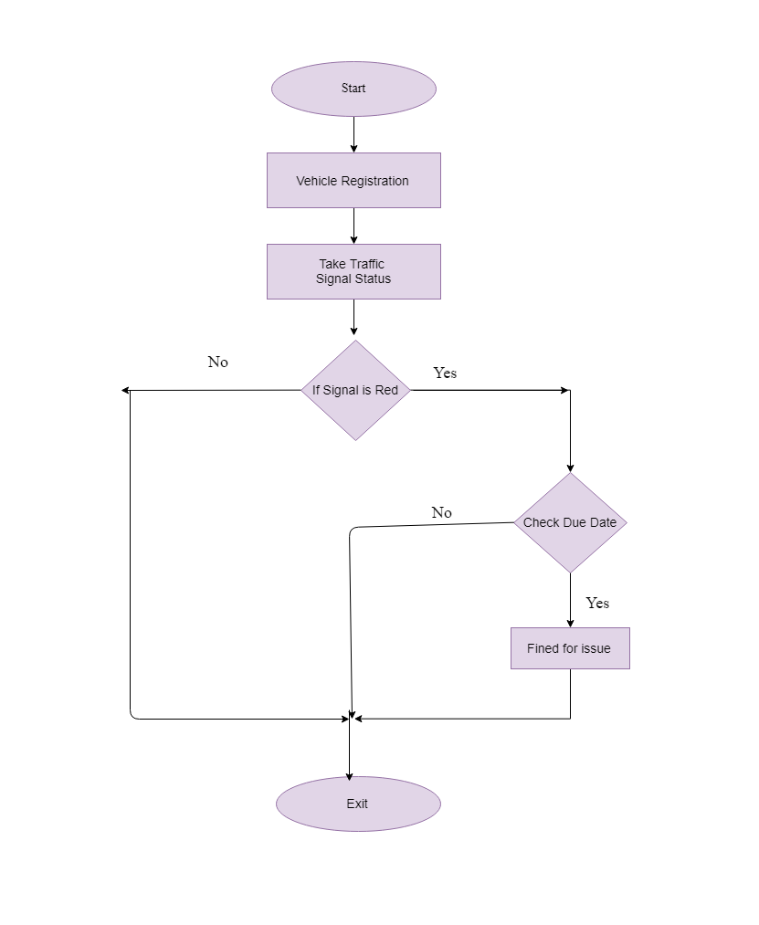
Fig-2: Graphical representation of flow of steps in No Parking process
No Parking: The present parking system is that police have to watch the vehicles parked in No parking area. There is more chance of people escaping from paying fine. So we came up with an idea of making this automatic using the RFID tag and Reader at No parking area. The Readers detect the vehicle entering the No parking area, If the vehicle is parked in No parking area more than specified time. Then the fine will be automatically generated and notified to user through SMS.

Signal Jump:The RFID Reader will be attached in the traffic signals. If any vehicles jump the signal when it is red, then fine will be generated and updated to database and fine amount will be notified to the owner through SMS.
DL verification: Here user fingerprint will be scanned to obtain the id from it. Obtained Id is used to verify the DL holder details. The Id is verified with the available data in database, If not exists or expired then fine is generated and notified to user through SMS.
Vehicle Document Verification: To overcome manual verification our system verifies each vehicle with the help of RFID. The reader detects the RFID tag and verifies the documents automatically. Complaint will be registered for vehicle with improper documents.

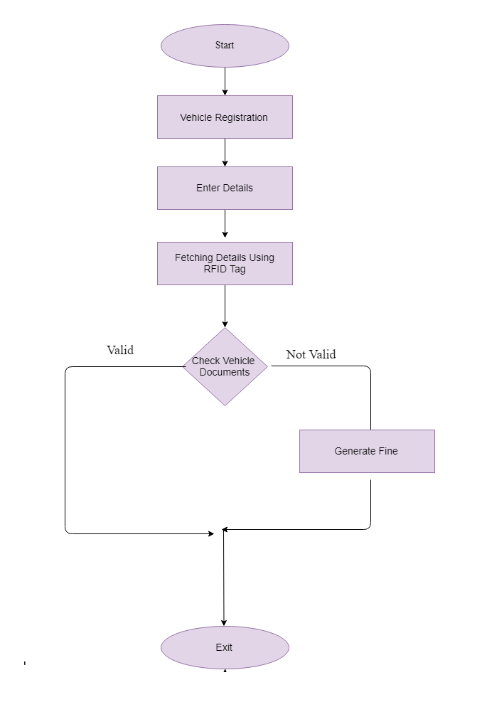
Fig-4: Driving License Flow chart.
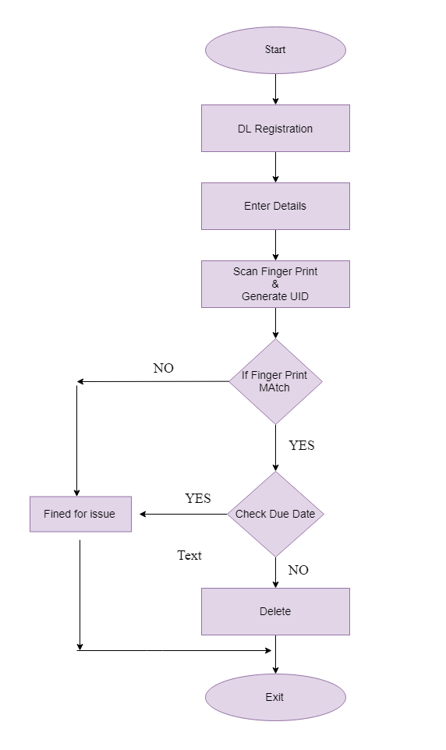

Fig-5: Vehicle document verification Flow chart.

Algorithm for Documents Verification.
Step 1 : Start
Step 2 : Register in the website with user details.
Step 3 : Get user Id.
Step 4 : Scan the RFID tag for verification.
step 5 : RFID Reader sends the data to the server.
Step 6 : If insurance date < current date Go to step 8
Step 7 : Register a complaint and notify the fine amount through SMS.
Step 8 : Start from Step 1.
Step 9 : End.

Algorithm for Vehicle document verification
Step 1 : Start
Step 2 : Scan the FingerPrint By Using Biometric Device.
Step 3 : Get ID and Verify the User Details in the Server.
Step 4 : If all Documents are Valid, then Go to step 6.
Step 5 : Register a complaint notify the fine Amount to the User through SMS.
Step 6 : Start from Step 1.
Step 7 : End.

V. CONCLUSION
The proposed method will successfully overcome existing system limitations. Our proposed system automatically detects the vehicles which violates the signal rules, vehicles parked in the no parking premises. All vehicles and DL holders should register with appropriate details with our system. In reference to the given details our system verifies and pushes the one with inappropriate documents to the complaint section, then notify this to customer by SMS. All these process run automatically once users registered with this system.

ACKNOWLEDGEMENT
We are Thankful to our guide Prof. Gururaj S P, Assistant Professor Dept. of CSE, SIT, Tumakuru.
REFERENCES
- I Chitresh, S and Amit K. ‘An efficient Automatic Attendance’. International Journal on Computer Science and Engineering (IJCSE).
- Victor S, Jonathan M, Reece J, and Lemire J. ‘Student Wolfpack Club Tracking System’. North Carolina State University in 2003.
- Tejonidhi Aphale, Rahul Chaudari, Jinit Bansod. ’Automated Toll plaza using RFID and GSM’. International Journal on Recent and Innovation Trends in Computing and Communication .
- Narendra Singh Pal, Abhishek Singh, depanshu Malik. ’RFID Based Biometric Electronic Voting Machine’. International Journal of Scientific Research and Management Studies.
- Vimal Surendran,Vignesh K S,Srikesh Baburaj, Vishnu V S,Krishnaveni S R.RFID based toll collection system..International Journal of Computer Science and Information Technology & Security (IJCSITS).

