Role of Syzygium Cumini (Jamun) in cosmetic
¹Mayuri A Parate, ²Dr. Nibha D Bajpai, ¹Dipalini D Walke

¹P.G student of cosmetic technology, ²Assistant Professor
Department of Cosmetic Technology
LAD and Smt. R P College for Women, Seminary Hills, Nagpur Maharashtra, India
¹Mayuriparate22@gmail.com, ²nibhabajpai@yahoo.co.in, ¹dpwalke1@gmail.com

Abstract - Plants have been used since the dawn of time for food, medicine and cosmetic. Plant can have intense effect on the skin, if used properly. A botanical ingredients as a component of a cosmetic may be defined as substance that originates from plants e.g Syzygium cumini known as ‘Jamun’ belonging to family Myrtaceae. The astringent properties of Syzygium cumini which help to prevent acne, blemishes, pimples etc. It also act as anti-aging, skin conditioning, hair growth promoter, surfactant, color, antimicrobial, antifungal, anti-inflammatory, antibacterial , photo protection agent etc. The main constituent of Syzygium cumini are flavonoids, tannin, essential oil, Gallic acid, oxalic acid, malic acid, betulic acid, terpenoids, saponin etc. Syzygium cumini has pharmacology and Ayurveda properties. With these properties Syzygium cumini can be used in cosmetic preparation. The current review highlights importance of Syzygium cumini in cosmetic.

Keywords: Syzygium cumini, Jamun, Phytoconstituents, Pharmacological activities, cosmetic uses.

I. Introduction:
The term ‘Natural’ means useful raw material that we get from Earth. They occur naturally and human can use to make more complex product which are beneficial to us. The word ‘Herb’ has been derived from the Latin word ‘Herba’. Herb refers to any part of plant like fruit, leaves, seed, flower, bark, stem etc. Since ancient civilization, plant have been used in pharmacology, Ayurveda and medicinal system. Plants contain many complex compounds like flavonoid, tannin, alkaloids, terpenoids and phenols etc. which are beneficial for human. Plant such as Azadirachta indica, Holy Basil, Curcuma longa, Santalum album etc. cure a several common ailments and give beneficial effect for skin and hair.
There are numerous herbs in India which are used for medicinal and cosmetic properties. Syzygium cumini is one of them which have been used from ancient time in pharmacology and Ayurveda. Jamun is a very common, big evergreen beautiful tree of Indian subcontinent. The scientific name of Jamun is Eugenia jambolana Lam or Syzygium cumini Linn belongs to family Myrtaceae [1]. Different parts of Syzygium cumini such as bark, seed, leaves, fruits [fig.2] have been used in medicine for diabetes, antimicrobial, antifungal, anti-inflammatory etc [2]. The leaves of Syzygium cumini are used to strengthen the teeth and gum [3]. Anthocyanin from Syzygium cumini can be considered a very useful approach to the food, pharmaceutical and cosmetic industries for colorants and beneficial to human health [4]. Syzygium cumini leaves contain tannin, flavonoids and polyphenols which are responsible for antioxidant, antimicrobial, photo protection capacity for a single UV-filter substance [5]. The presence of anthocyanin present in pulp are important in reducing the oxidative stress-induced diseases. Leaf extract of Syzygium cumini also reduce the radiation induced DNA damage in the cultured human peripheral blood lymphocytes [6]. Fruits of Syzygium cumini are used in Siddha, Ayurveda, Unani besides other folklore system of medicine in India as stomachic, astringent, antiscorbutic, diuretic, ant diabetic, enlargement of spleen and chronic diarrhea [7]. Ayurveda properties and pharmacological properties of Syzygium cumini have benefit for human skin, hair and oral care because of presence of phytoconstituent.

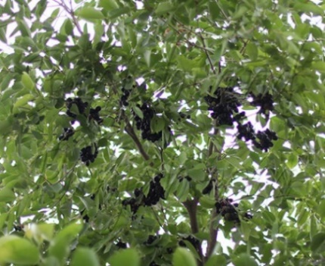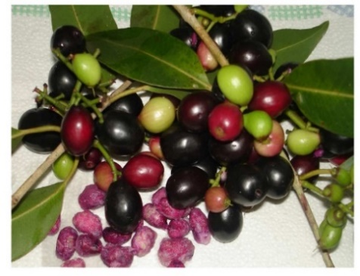

Fig. 1 Syzygium cumini tree [8] Fig. 2 Syzygium cumini fruit, seed, leaves, bark [9]

Table 1 showing different names of Syzygium cumini.

Table 1 Synonym of Syzygium cumini [10]

Latin name | Syzgium cumini
English name | Java plum, black plum
Hindi name | Jamun, Jambol, Jambul
Bengali name | Kala jam
Punjabi name | Jamalu
Telugu name | Neredu, Chettu
Kannada name | Nerale
Malayalam name | Naval

Table 2 showing botanical description of Syzygium cumini.

Table 2 Botanical description of Syzygium cumini [11]

Kingdom | Plantae
Divison | Angiosperms
Sub Division | Eudicots
Order | Myrtaceae
Family- | Myrtaceae
Genus | Syzygium
Species | Cumini

II. Origin and distribution:
Syzygium cumini is originated from India or the East Indies. It is found in Thailand, Madagascar, Philippines and some other countries. The plant introduced into sub-tropical region including Florida, California, Algeria and Israel. It also occurs in lower range of Himalayas up to an elevation of 1300 meters and in kumaon hills up to 1600 meters. It is widely grown in the larger parts of India from indo-gangetic plains in the north to Tamilnadu in the south [12, 13].

III. Morphology Character
It is a long lived big evergreen tree, height up to 25-30 meter. The trunk has 3 to 4 meter circumference with a semi spreading crown up to 10 meter in diameter and it is thick and grayish white in color. The branches are wide spreading and bend at the ends. It has deep tap root system and root is wiry, while the lateral roots are numerous, long and distributed down the main root. Leaves are simple, glossy elliptic, pinnately veined with lateral veins close together. It carries with a few flowers in a panicle. Flowers are light yellow and hermaphrodite, carry in the axils of leaves on branchlet, calyx lobes, calyx tube, petals, white spreading, stamens, ovary inferior and 2 celled. Fruit is a berry, purplish red, ovoid and edible [6].

Table 3 Phytoconstituent reported from different parts of Syzygium cumini [14, 15, and 16].

Sr.No. | Parts | Constituents
1 | Root | Flavonoid glycosides, and isorhamnetin 3-O-rutinoside.
2 | Bark | n-betulinic acid, friedelin, epi-friedelanol, β-sitosterol, Eugenie and fatty acid ester of epi-friedelanol, β-sitosterol, quercetin kaempferol, myricetin, Gallic acid and ellagic acid, bergenins, flavonoids and tannins. The presence of Gallo- and ellagitannins may be responsible for the astringent property of stem bark.
3 | Fruit | Raffinose, glucose, fructose (Srivastava, 1953), citric acid (Winton, 1935), mallic acid (Lewis, 1956) and Gallic acid. The sourness of fruits may be due to presence of Gallic acid. (Venkateswarla (1952) and Rastogi &Mehrotra) (2001) reported that the color of the fruits might be due to the presence of anthocyanin namely delphinidin-3-gentiobioside and malvidin-3- laminaribioside along with petunidin-3- .The fruit contains 83.70–85.80 g moisture, 0.70–0.13 g protein, 0.15–0.30 g fat, 0.30–0.90 g crude fiber, 14.00 g carbohydrate, 0.32–0.40 g ash, 8.30–15.00 mg calcium, 35.00 mg magnesium, 15.00–16.20 mg phosphorus, 1.20–1.62 mg iron, 26.20 mg sodium, 55.00 mg potassium, 0.23 mg copper, 13.00 mg sulfur, 8.00 mg chlorine, 80 I.U. vitamin A, 0.01–0.03 mg thiamine, 0.009–0.01 mg riboflavin, 0.20–0.29 mg niacin, 5.70–18.00 mg ascorbic acid, 7.00 mg choline and 3.00 mcg folic acid per 100 g of edible portion.
4 | Flower | Oleanolic acid; two other triterpenoids ellagic acids and flavanols isoquercetin, quercetin, kampferol and myricetin are present in small amounts whereas myricetin-3-L arabinoside, dihydromyricetin and quercetin galactosides have also been isolated (Subramanian & Nair, 1972).
5 | Leaves | Acylated flavonol glycosides, quercetin, myricetin, myricitin, myricetin 3-O-4-acetyl-L-rhamnopyranoside, triterpenoids, esterase, galloyl carboxylase, and tannin.
6 | Seed | Glycosides, a trace of pale yellow essential oil, fat, resin, albumin, chlorophyll (Nadkarni 1954), an alkaloid- jambosine (Chopra et al., 1956), Gallic acid, ellagic acid, corilagin and related tannin, 3,6- hexahydroxydiphenoylglucose and its isomer 4,6- hexahydroxydiphenoylglucose, 1- galloylglucose, 3- galloylglucose, quercetin (Bahtia & Bajaj, 1975) and elements such as zinc, chromium, vanadium, potassium and sodium (Ravi et al., 2004). Unsaponifiable matter of seed fat contains β-sitoterol (Gupta & Agrawal, 1970). Dry seeds of Syzygium cumini have been reported with 11.67% alcohol soluble extractive, 3.397% inorganic (Kar et al., 1999), 40% of water-soluble gummy fiber and 15% of water insoluble neutral detergent fibers (Pandey & Khan, 2002).
7 | Essential oil | α-Pinene, camphene, β-Pinene, myrcene, limonene, cis-Ocimene, trans-Ocimene, γ-Terpinene, terpinolene, bornyl acetate, α-Copaene, β-Caryophyllene, α-Humulene, γ-Cadinene and δ-Cadinene, trans-ocimene, cis-ocimene, β-myrcene, α-terpineol, dihydrocarvyl acetate, geranyl butyrate, terpinyl valerate, α-terpineol, β-caryophyllene, α-humulene, β-selinene, calacorene, α-muurolol, α-santalol, cis-farnesol: lauric, myristic, palmitic, stearic, oleic, linoleic, malvalic, sterculic and vernolic acids. Unsaponifiable matter of the seed fat was also chemically investigated.

IV. Phytochemistry:
In phytochemical ‘Phyto’ is the Greek word for plants. There are many families of phytochemicals and they help the human body in a variety of ways. Phytochemical are nonnutritive plant chemicals that have protective effect and disease preventive properties. Plant chemical will be considered under three main biogenetic classes – terpenoids, alkaloids, and related nitrogen compounds and phenolic [17].
The general properties and use of active constituent present in different plants. All these constituent are found in Syzygium cumini also [table 3]. Therefore it can also be used in cosmetic formulation.

Phenolic: Phenolic are hydroxyl group (-OH) containing class of chemical compounds where the (-OH) bonded directly with aromatic hydrocarbon group. The most important groups of phenolic are flavonoids, polyphenols, and phenolic acids [18]. (Maximilian Nierenstein) studied natural phenols found in different plant species in 1905. Phenolic compound are plant secondary metabolites, they have an important role as defense compounds. It act as antioxidant, antibacterial, anti-inflammatory agents. This compound used for many skin problems like acne, eczema, aging and healing [19].
These compound occur in free or glycosylated forms. Esculetin, Umbelliferone, and scopoletin are coumarins used in cosmetic as fragrance and skin whitening products. These compound have antiseptic action and used for skin infection [20].

Phenolic acids: Phenols possess one carboxylic acid functional group. Phenolic acid contain two carbon frameworks- the hydrocinnamic and hydroxybenzoic structure. These are secondary plant metabolites [20].
Activity of phenolic acid
Phenolic acid have been studied mainly for their properties against oxidative damage leading to various degradative disease [21]. These compound are produced in response to different stresses such as infection,wounding,UV radiation, ozone, pollutants etc. polyphenolics are used in cosmetic industry as a natural additives like natural coloring agent, antioxidant etc[22]. Cosmetic preparation containing phenolic extract are sold with the claims of ant aging , wound healing and photo protection etc. polyphenols can be cause skin irritation , inflammation, allergic reaction and can induce skin pigmentation defects. Phenolic acid are protectors through reduction of oxidative stress, inflammation and may be important component in cosmetic formulation for post-sun skin care [20].

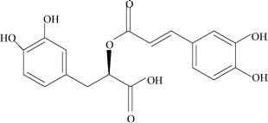
Fig. 3 Structure of phenolic acid [23].

Flavonoids: Flavonoids are polyphenolic compounds that are present in nature. The six membered ring condensed with the benzene ring is either pyrone or its dihydroderivative. The position of the benzenoid substituents divides the flavonoids into two classes- Flavone and isoflavone [24].
Activity of flavonoids
Flavonoids are secondary plant metabolites share the chromane ring with tocopherols, these compound show antioxidant activity. In this activity major mechanism is induce direct scavenging of oxygen and nitrogen free radical, inhibition of oxyradical producing enzymes ,iron chelation and reduction of leukocyte adhesion to the blood vessel wall during tissue inflammation and reperfusion. In cosmetic flavonoids important for skin aging activity. Flavonoids like kaempferol delay skin aging by constrasting enzyme that break down the extracellular matrix, such as collagenase, elastases and hyaluronidases. Phytoestrogen are used to control menopausal problem but they also improve the quality of the skin and slow the effect of aging. Equol use for skin altered states like acne, eczema, skin eruption [20].

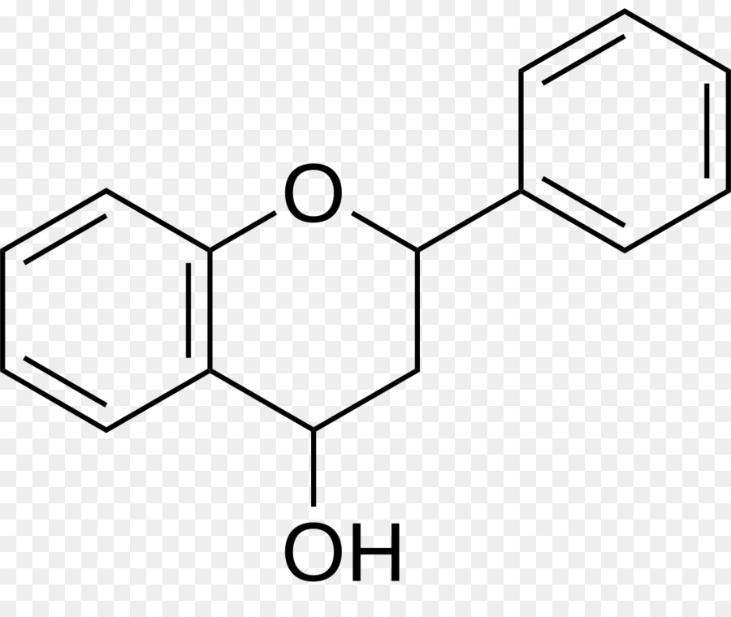
Fig. 4 Structure of flavonoid [25].

Tannin: Tannin are heterogeneous group of high molecular weight polyphenolic compounds with proteins, polysaccharides, alkaloids, nucleic acids and minerals etc [26]. Tannins are divided into four group on the basis of its structure- Gallotannins, Ellagitannins, complex tannins, condensed tannins. (Maximilian Nierenstein) studied natural tannins found in different plant species in 1905 [27].
Activity of tannins
Tannins also have important cosmetic properties used in anti-aging skin care to prevent hair loss [28]. Tannin contain precipitate protein which are used for protection of inflamed surface of skin and treatment of burns. It is also act as antimicrobial activity [29].
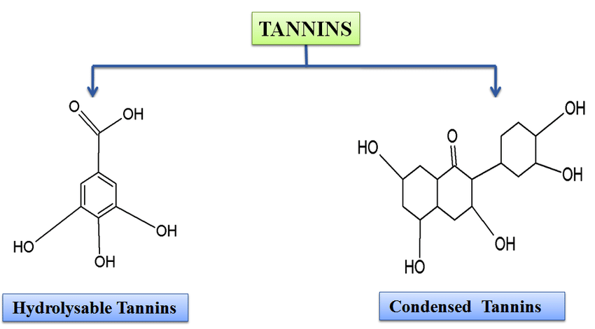
Fig. 5 Structure of tannin [30].

Alkaloids: The name "alkaloids" was introduced in 1819 by the German chemist (Carl Friedrich Wilhelm Meißner) .Alkaloids contain heterocyclic nitrogen atoms. Alkaloids derives from the alkaline and used to describe any nitrogen containing base. They formed salts with acid [31].
Activity of alkaloids
Alkaloids are responsible for antibacterial and antifungal activity. Pyridine alkaloids have been found to present strong antimicrobial properties and have antioxidant activities due to their ability to act as scavenger of free radicals, hydrogen donation or electron or metal chelating activity [32].
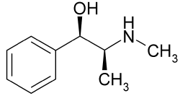
Fig. 6 Structure of Alkaloid [33].
Terpenoids: Terpenoids derived from five carbon isoprene units. Terpenes are found in nature mainly in plant as constituents of essential oils [34]. Terpene hydrocarbon have molecular formula (C₅H₈)n and they are classified according to number of isoprene units (Gershenzon and Croteau, 1991) [35].
Hemiterpenoids, monoterpenoids, sesquiterpenes, diterpenes, triterpenes, tetraterpenoids
Activity of terpenes
Ancient civilization Egyptian used terpenoids as ointment or for bathing. Plant oils contain terpenes inhibiting species of bacteria [36]. Terpene are used in cosmetic industry for generating flavors and fragrance due to their pleasant scent. Recent reports on analysis of their free radical scavenging capacity have suggested that they can act as antioxidant. Triterpenes are particularly useful compounds for dermatological conditions. Ursolic acid, for example, widely diffused in many plants, is a pentacyclic triterpene used in cosmetic preparations for skin revitalization [20].
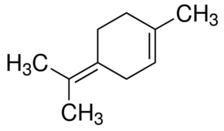
Fig. 7 Structure of terpene [37].

Saponin: Saponin are secondary plant metabolites distributed in the plant kingdom. Chemically saponins are steroids, triterpenoids and steroid alkaloids [38]. Saponin that contain one sugar molecule attached at the C-3 position are called monodesmoside and saponin that contain minimum of two sugar ,one attach to the C-3 and one at C-22 are called bidesmoside saponin [39].
Activity of saponin
Saponin are known as natural surfactant, they form a stable foam in aqueous solution such as soap. They are also use in shampoo, liquid detergent, toothpaste, and also use as emulsifier and long lasting foaming agent [40]. Extract of saponin use as active ingredient in cosmetic for antioxidant, regenerative, and ant aging properties [20].

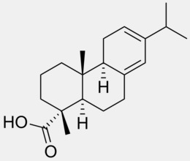
Fig. 8 Structure of Saponin [41].

Hydroxyl acids: The group of alpha hydroxyl acids (AHAs) also known as fruit acids includes glycolic, citric, malic and lactic acids. AHAs use in skin care therapy for the treatment of wrinkles as exfoliating agents, they induce a thinning effect on the stratum corneum, involving desquamation, cell renewal and collagen synthesis with an increase in the thickness of the dermis [20].

V. Pharmacology activities
Antioxidant: Antioxidant play important role by prevent the formation of reactive oxygen species by reducing hydroperoxides and scavenging free radicals. Antioxidant activity may be due to compound such as flavonoids, isoflavones, flavones, vitamin C, E and beta carotene [42]. In phenolic antioxidant activity due to their redox potential which allow them to act as hydrogen donors, singlet oxygen quenchers, metal chelators [43].Methanolic leaf extract of Syzygium cumini rich in phenolic, saponin, flavonoids, and tannins. The antioxidant activities of the methanolic extracts were measured on the basis of the free radical scavenging activity of the stable 1, 1-diphenyl-2-picrylhydrazyl (DPPH) free radical, following the method described by (Braca et al.) (2001). Sample extract of 0.1 ml was added to 3 ml of a 0.004% of DPPH and the mixture was let stand for 30 min. Absorbance at 517 nm (CE2021, 2000 series CECIL Instruments™ Cambridge, England) was determined after 30 min incubation and the percent inhibition activity was calculated as: % Antioxidant activity = [(AB – AS)/ AB] x100 Where AB is absorbance blank, while AS is absorbance of sample tested [44].
Antimicrobial property: Hydro alcoholic extract of leaves of Syzygium cumini contain tannins and other phenolic constituents which are responsible for antimicrobial property. It has potential against multi resistant and standard strains of Staphylococcus aureus and Pseudomonas aeruginosa may be explored in order to develop a topic antimicrobial therapy to promote skin wounds healing [45]. Jamun is known to be very rich in Gallic and ellagic acid. (Gangadhar et al )., studied the antibacterial activity against E. coli, B. subtilis, P. aeruginosa and S. aureus and inhibitory effect on glucoamylase of ethanolic extracts isolated at different temperatures from seeds of Syzygium cumini was investigated in vitro. The ethanolic extracts of leaves and aqueous extracts of seeds were found to have very high anti-microbial property for wide range of gram positive and gram negative bacterial strains [46].

Preservation: Syzygium cumini leaf extract may be used as natural preservative ingredients in food and pharmaceutical industries due to their antioxidant and antibacterial properties [47].

Anti-inflammatory: (Muruganandan et al.)(1994) and (slowing et al.)(2001) reported the anti-inflammatory property of bark and leaf. Ethanolic extract of bark and extract of seed of Syzygium cumini has anti-inflammatory property. The stem bark ash of Syzygium cumini mixed with water or oil used as an anti-inflammatory agent and used to treat burns [48, 49]. Ethanolic extract of Syzygium cumini bark has been reported to possess anti-inflammatory activity against histamine, serotonin and prostaglandin. For this study inflammation was induced by individual autacoids insult, Histamine (1mg/ml), serotonin (5-HT, 1mg/ml), Bradykinin (0.02mg/ml) and prostaglandin (PGE2, 0.001mg/ml) was used as inflammogens. When injected in rat paw, ethanolic extract showed anti-inflammatory effects in histamine, PGE2 and 5-HT induced rat paw oedema [50].

Antibacterial: Syzygium cumini essential leaf oil were tested for their antibacterial property. Syzygium cumini leaves, bark and seed are a good source of malic and oxalic acids, tannins which are responsible for antibacterial property. Syzygium cumini fruit polyphenol extract having a broad spectrum antimicrobial activity against pathogenic strains, Staphylococcus aureus, s.aureus, Escherichia coli, Klebsiella pneumonia and Candida albicans minimum inhibitory concentration in the range from 0.5 to 2.5 mg/ml [51]. (Shaikh et al.) have investigated antibacterial activity of ethanolic extracts of Syzygium cumini against gram positive and gram negative organisms. Bhuiyan et al., reported antibacterial activity of methanol and ethyl acetate extracts of the seeds of Syzygium cumini at a concentration of 200 µg/disc against five Gram positive bacteria (Bacillus creus, B. subtalis, B.megateriun, Steptococcus ß – haemolyticus, S. aureus) and nine Gram negative bacteria (Shigella dysenteriae, Sh. Shiga, Sh. boydii, Sh. flexneriae, Sh.sonnei, E. coli, S. typhi B, S. typhi B- 56 and Klebsicella species) by disc diffusion method [52].

Antifungal property: Syzygium cumini seed extract has antifungal property show activity against Candida albicans and Aspergillus Niger [51]. (Chandrasekaran and Venkatesalu) reported that the aqueous and methanolic extracts of Syzygium cumini seeds possess antifungal activity against dermatophytic fungi, i.e., Candida albicans, Tricophyton rubrum, T. mentagrophytes and Microsporum gypseum the methanolic extract is also reported to possess antifungal activity against Aspergillus Niger [53].

Oral property: Syzygium cumini leaves extract has antibacterial property helps in strengthening and preventing teeth and gums from various infection. The branches are used to whiten the teeth. Ash of jamun leaves is used in making tooth powder and manjan [54].

Hair growth property: Ethanolic extract of seed and fruit pulp of Syzygium cumini were incorporated in oleaginous base that applied on shaved skin of albino mice. Albino mice were examine for hair growth activity. From this study it can be conclude that the ethanolic extract of fruit pulp have more pronounced effect when compared to the seed extract. Syzygium cumini fruit pulp extract have a significant potency in promoting hair growth [55].

Coloring property: Syzygium cumini bark contain 13-19% tannins. It has perform in tanning and yield brown dye used in coloring. Syzygium cumini fruit contain high level of anthocyanin cab be good source of natural colorant for pharmaceutical industries [56,4] Total anthocyanin content was determined by the spectrophotometric method (Esti et al. 2002). Sample of 10 mg powder were extracted with twice the time of 10 ml of HCl/ water/ethanol solution (1/29/70). The sample extract was then centrifuged for 10 min at 10,000g and recorded in a Beckman D Estimation U-640 spectrophotometer (Beckman Coulter, Fullerton, USA). Total anthocyanin content was expressed as cyanidin-3-rutinoside [57]

VI. Cosmetic uses
Syzygium cumini contain phytoconstituent like tannin, flavonoids, phenols, alkaloids, terpenoids which can provide cosmetic property due to which it can be used in various cosmetic products.
Syzygium cumini fruits which attributes to its antioxidant and free radical scavenging activity due to the presence of high level of anthocyanin content. However, many studies have conclusively shown that the majority of the antioxidant activity may be due to compounds such as flavonoids, isoflavones, flavones and anthocyanin rather than the traditionally considered vitamins C, E and β-carotene [58]. According to Yamaguchi, the flavonoids show antioxidant and ant aging properties but also protect the skin from UV radiation. In phenolic antioxidant activity due to their redox potential which allow them to act as hydrogen donors, singlet oxygen quenchers, and metal chelators [43]. Blue light is high energy visible light emitted from phone or screens which cause wrinkle, acne pigmentation via free radical generation induce oxidative stress in live skin which leads to damage DNA causing inflammation and breakdown of collagen and elastin. To prevent damage of caused by blue light use natural antioxidant. Syzygium cumini extract has antioxidant property it prevent formation of reactive oxygen species by free radicals. Methanolic leaf extract of Syzygium cumini was rich in phenolic, saponin, flavonoids, and tannins. Syzygium cumini of methanol extract and leaf essential oil cab be considered good sources of natural antioxidants[59,60,61].Syzygium cumini oil is used as an antiseptic and as a perfume in cosmetic [62]. Jamun contain thiamine (vitamin B1) [63] use for Fragrance Ingredient; Skin-Conditioning Agent. The presence of vitamin C is beneficial for fair skin complexion. Syzygium cumini can help lighten skin pigmentation .It help to purifying your blood and keeping your skin clean and glowing. It is rich in iron and also improves the hemoglobin content in the body. Astringency of the fruit is due to presence of phenolic compounds. Its astringent property makes it able to keep oily skin fresh, smooth and acne free [64]. Due to the presence of oxalic acid, Gallic acid, malic acid, tannins, betulic acid and etc . Syzygium cumini root, bark, flower, and leaves contain terpene mainly sesquiterpene are volatile compound. Saponin and triterpene having both hydrophilic and lipophilic properties [65].
The antibacterial property of its leaves helps in strengthening as well as preventing teeth and gums from various infections [54]. Syzygium cumini fruit pulp extract have a significant potency in promoting hair growth [55]. Syzygium cumini fruit contain high level of anthocyanin cab be good source of natural colorant for cosmetic processing industries. The bark contains 13 - 19% tannins it has served in tanning and also yields a brown dye that has been used in coloring [56, 4]. Syzygium cumini extract exhibited a significant photo protection capacity for a single UV-filter substance [66].
Work should also be done on the methods of preservation of this fruit like other valuable fruits because it is full of nutrition particularly phytochemicals.

VII. Conclusion
Syzygium cumini is a very common, big evergreen beautiful tree of Indian subcontinent. Since ancient time Syzygium cumini is used for pharmacological action, Ayurveda and medicinal uses. Scientific studies conducted of phenol for UV radiation showed [66], it can be utilised in cosmetics. Syzygium cumini contains complex mixture of many plant metabolites, such as alkaloids, glycosides, terpenoids, flavonoids, anthocyanin, and tannins. Extract of syzygium cumini with these constituents can be used in appropriate formulation of cosmetic product to prevent acne, blemishes, wrinkles and pimples and can be used as anti-aging, skin conditioning, hair growth promoter, strengthen teeth, surfactant, photo protection, antimicrobial etc .The present review highlights on the use of syzygium cumini for skin and hair benefits which help to formulate cosmetic products. Its properties can be explored in cosmetic industries to use in various cosmetic formulation.

Reference:
1. Shrikant Baslingappa Swami, Nayan Singh J. Thakor , Meghatai M. Patil , Parag M. Haldankar. Jamun (Syzygium cumini (L.)): A Review of Its Food and Medicinal Uses .Food and Nutrition Sciences, 2012, 3, 1100-1117
2. Rhahman AU, Zaman K. Medicinal plants with hypoglycemic activity. J Ethnopharmacol 1989; 26: 1-55.
3. Warrier PK, Nambiar VP, Ramankutty C. Indian Medicinal Plants. Hyderabad: Orient Longman Ltd; 1996
4. Do Carmo Brito BN, da Silva PenaR, SantosLopesA, CamposChistéR.Anthocyanins of Jambolão (Syzygium cumini): Extraction and pH-Dependent Color Changes. J Food Sci. 2017 Oct; 82(10):2286-2290. doi: 10.1111/1750-3841.13847. Epub 2017 Aug 23.
5. Ross JA, Kasum CM Dietary flavonoids: bioavailability, metabolic effects, and safety. Annu Rev Nutr 22:, 2002, 19-34
6. D.S. Mishra, Akath Singh, Rajesh Kumar, Sanjay Singh, A.K. Singh and G.S.K.Swamy. Jamun. Tropical and Sub tropical Fruit Crops: Crop Improvement and Varietal Wealth Part.II (Ed) Ghosh, S.N. Jaya Pub. House, Delhi pp. 375-387.
7. S Ramya1, K Neethirajan1 and R Jayakumararaj. Profile of bioactive compounds in Syzygium cumini – a review. Journal of Pharmacy Research 2012, 5(8),4548-4553
8. http://punjabiandpunjab.com/Herbs/Syzygium_cumini.html
9.https://www.researchgate.net/figure/Eugenia-jambolana-Lam-Jamun-berries-and-seeds-picture-by-NS-from-fruits-collected-in_fig5_23936718
10. Veeram Anjali, G. Sindhu, C.Girish .A review on pharmacology and phytochemistry of syzygium cumini. Indian J. Pharm. Biol. Res. 2017; 5(4):24-28
11. V.M. Jadhav, S.S. Kamble, V.J. Kadam. Herbal medicine: Syzygium Cumini: A Review Journal of Pharmacy Research 2009, 2(8), 1212-1219
12. Ross, I. A. Medicinal Plants of the World, 2 nd edition, Volume-1, Humana.
13. Sanjay Singh, A.K Singh, H.K Joshi, B.G Bagle, D.G Dhandar .Jamun –A fruit for future Central institute for Arid Horticulture, Bikaner 2007.
14. Meenakshi Kumawat, Jyoti Damor, Jaya Kachchhwaha, Ayush Kumar Garg and Chandan Singh PHARMACOLOGICAL PROPERTIES AND THERAPEUTIC POTENTIAL OF SYZYGIUM CUMINI (JAMUN): A REVIEW World Journal of Pharmaceutical Research SJIF Impact Factor 7.523 Volume 7, Issue 03, 312-322.
15.Vijayanand P, Rao LJM, Narasimham P. Volatile flavor components of Jamun fruit (Syzygium cumini) Flavour Fragrance J. 2001;16:47–49.
16.https://shodhganga.inflibnet.ac.in/bitstream/10603/11755/5/05_chapter%202%20a.pdf
17. Nicholas J. Walton, Diane E. Brown Chemicals from Plants: Perspectives on Plant Secondary Products. Institute of food Research, Norwich laboratory, UK 1999
18. Walton NJ, Mayer MJ, Narbad A. Molecules of Interest: Vanillin. Phytochemistry, 2003; 63: 505- 515.
19. Dai J, Mumper R. Plant phenolic: extraction, analysis and their antioxidant and anticancer properties. Molecules, 2010; 15: 7313-7352.
20. Bruno Burlando, Luisella Verotta, Laura Cornara, and Elisa Bottini-Massa. Traditional Herbal Medicines for Modern Times. Herbal Principles in Cosmetics Properties and Mechanisms of Action by Taylor and Francis Group, LLC CRC Press is an imprint of Taylor & Francis Group, an Informa business.2010 (9-26)
21. Mandal SM, Chakraborty D, Dey S. Phenolic acids act as signaling molecules in plant–microbe symbioses. Plant Signal Behav, 2010; 5: 359-368.
22. Munin, A.; Edwards-Lévy, F. Encapsulation of natural polyphenolic compounds: A review. Pharmaceutics2011, 3, 793–829.
23. https://www.medicinalplantsarchive.us/medicinal-plants-2/phenolics.html
24. Tapas AR, Sakarkar DM, Kakde RB. Flavonoids as Nutraceuticals: A Review. Tropical Journal of Pharmaceutical Research, 2008; 7: 1089-1099.
25. https://www.kisspng.com/png-flavonoid-flavones-phenols-flavan-3-ol-flavanone-2613148/
26. Mueller-Harvey I, Mcallan AB. Tannins: Their biochemistry and nutritional properties. Advances in plant cell biochemistry and biotechnology, Vol. 1 Morrison IM ed. JAI Press Ltd, London (UK), 1992; 151-217.
27. Mole S, Waterman PG. Tannic acid and proteolytic enzymes: enzyme inhibition or substrate deprivation. Phytochemistry, 1987; 26: 99-102
28. Akiyama H, Kazuyasu F, Yamasaki O, Oono T, Iwatsuki K. Antibacterial action of several tannins against staphylococcus aureus. Journal of antimicrobial chemother 2001; 48: 487‐491.
29. Grujic-Vasic J1, Bosnic T, Jovanovic. M. The Examining of Isolated Tannins and their Astringent Effect. Journal of Planta Medica. 1986; 1(6):548-550
30.https://www.researchgate.net/figure/Figure1-Types-of-tannins-and-their-basic-structures-Tannins-in-therapeutics-Researchers_fig1_277029056
31. Rao RVK, Ali N, Reddy MN. Occurrence of both sapogenins and alkaloid lycorine in Curculigo orchioides. Indian Journal Pharma Science, 1978; 40: 104-105.
32. Molyneux RJ, Nash RJ, Asano N. Alkaloids: Chemical and Biological Perspectives, Vol. 11, Pelletier SW, ed. Pergamon, Oxford, 1996; 303.
33. https://www.newworldencyclopedia.org/entry/Alkaloid
34.Elbein AD,Molyneux RJ.Comprehensive Natural product Chemistry, Volume 3, Barton D and Nakanishi K,ed. Amsterdam 1999;129
35. Langenheim JH. Higher plant terpenoids: A phytocentric overview of their ecological roles. Journal of Chemical Ecology, 1994; 20: 1223- 1280
36. Caputi L., Aprea E. Use of terpenoids as natural flavouring compounds in food industry. Recent Pat Food Nutr Agric., 2011, 3, 9–16.
37. http://theleafonline.com/c/science/2015/01/terpene-profile-terpinolene/
38. Bohlmann J, Meyer-Gauen G, Croteau R. Plant terpenoid synthases: Molecular biology and phylogenetic analysis. Proc Natl Acad Sci USA, 1998; 95: 4126–4133.
39. Lasztity R, Hidvegi M, Bata A. Saponins in food. Food Review International, 1998; 14: 371-390.
40. Tanaka, O.; Tamura, Y.; Masuda, H.; Mizutani, K. In Saponins Used in Food and Agriculture; Waller, G.R., Yamasaki, K., Eds.; Plenum Press: New York, NY, USA, 1996; pp. 1–11.
41. https://www.kissclipart.com/free/saponin.html
42. Liu F, Ng TB. Antioxidative and free radical scavenging activities of selected medicinal herbs. Life Sci. 2000; 66:725–735
43.Yamaguchi, L.F., Vassão, D.G., Kato, M.J. and Mascio, P. Biflavonoids from Brazilian Pine Araucaria angustifolia as Potentials Protective Agents against DNA Damage and Lipoperoxidation. Phytochemistry, 2005, 66, 2238-2247.
44. SartajAlia, Tariq Masudb, Kashif Sarfraz Abbasic, Amjed Alia, Azhar Hussaina. Some compositional and biochemical attributes of jaman fruit (Syzygium cumini L.) from Potowar region of Pakistan Research in Pharmacy, 2013, 3(5): 01-09.
45.Mahmoud, I.I.; Marzouk, M.S.A.; Moharram, F.A.; El–Gindi, M.R.; Hassan, A.M.K. Acylated flavonol glycosides from Eugenia jambolana leaves. Phytochemistry, 2001, 58, 1239–1244
46. Amol Changdeo Dagadkhair, Komal Nivrutti Pakhare, Ashok Dattatray Todmal and Rajkumar Ramrao Andhale Jamun (Syzygium cumini) Skeels: A Traditional Therapeutic Tree and its Processed Food Products. Int. J. Pure App. Biosci. 2017, 5 (5): 1202-1209
47. Amal A. Mohamed, Sami I. Ali, Farouk K. El-Baz Antioxidant and Antibacterial Activities of Crude Extracts and Essential Oils of Syzygium cumini Leaves. April 12, 2013
48. Chandhuri AKN, Pal S, Games A, Bhattacharya S. Anti-inflammatory and related actions of Syzigium cumini seed extract. Phytotherapy Res 4: 1990, 5–10
49.Gordon A, Jungfer E,da Saliva BA,Maia JG,Marx Phenolic constituents and antioxidants capacity of four underutilized fruits from the Amazon region.JAgr Food Chem 2011;59:7688-7699.
50. Abhishek Kumar Sah and Vinod K. Verma.Syzygium cumini: An overview .J. Chem. Pharm. Res., 2011, 3(3):108-113.
51. Singh JP, Kaur A, Singh N, Nim L, Shevkani K, Kaur H, Arora DS, LWT - Food Science and Technology, 2016, 65, 1025.
52. https://shodhganga.inflibnet.ac.in/bitstream/10603/11755/5/05_chapter%202%20a.pdf
53. Sneha Sehwag and Madhusweta Das Nutritive, therapeutic and processing aspects of Jamun, Syzygium cumini (L.)Skeels- An overview Indian Journal of Natural Products Resources Volume 5(4), December 2014 pp. 295-307
54. Mahreen Akhtar, Muhammad Atif Randhawa and Zafar Iqbal. Nutritional, Therapeutic and food Application of Jamun (syzygium). Faculty of food Nutritional and home science volume 1, Issue 1, August 2016.
55. Neetu Gautam, Sakshi Sehgal, Vineet Gupta Rajiv Gupta Hair growth activity of seeds and fruit pulp of Eugenia jambolana (Jamun) 2015Volume 2 Issue 6 - India
56. M.Leon.Development of a cosmetic product using a natural dye extracted from Jambolan fruit (Syzygium cumini (L). Skeels) March 2015
57. https://shodhganga.inflibnet.ac.in/bitstream/10603/212522/12/12.%20chapter%20-%20iii.pdf
58. Payel Ghosh, Rama Chandra Pradhan, Sabyasachi Mishra, Avinash Singh Patel and Abhijit Kar. Physicochemical and Nutritional Characterization of Jamun (Syzygium Cuminii).Current research in nutrition and food science.2017
59. Roger L. Mc Mullen, Antioxidant and the skin, 2nd edition, published by CRC press Taylor and France group 6000 broken sound parkway NW, suite 300 Baca Raton, FL 2019 33487-2742.
60.Cosacon GmbH, blue light august 2018
61. L. Joji Reddy, Beena Jose. Evaluationof Antibacterial and DPPH Radical Scavenging Activities of the Leaf Extract and Leaf Essential oil of Syzygium Cumini Linn. From South India. International Journal of Pharmacy and Pharmaceutical Sciences ISSN- 2013 0975-1491 Volume 5, Suppl 3.
62. Steffen Arctander Perfume and Flavor Materials of Natural Origin.Elizabeth, N.J (U.S.A) 1996,176
63. D. K. Salunkhe, S.S. Kadam .Handbook of Fruit Science and Technology: Production, Composition, Storage.1995, 575.
65. A. Weizmann and Y. Mazur, “Steroids and triterpenoids of citrus fruit. II. Isolation of citrostadienol,” The Journal of Organic Chemistry.1958, volume. 23, no. 6, pp. 832–834.
64. Dr. Afifa Jahan .Jamun a fruit with high nutritional and medicinal value. Health action September 2018
66. Rebeca M Lima, Hudson C Polonini, Marcos AF Brandão, Francisco J Raposo, Rafael C Dutra and Nádia RB Raposo In vitro Assessment of Anti-aging Properties of Syzygium cumini (l.) Leaves Extract. Biomed J Science & Technology Res. January 28, 2019.

