UV SPECTROPHOTOMETRIC ANALYSIS AND VALIDATION OF BENZOYL PEROXIDE IN SOLID DOSAGE FORM

Akshata Lasure*¹ Afaque Ansari¹, Dr. Mallinath Kalshetti¹
D.S.T.S. Mandal’s College of Pharmacy, Solapur-413004 Maharashtra, India.

For Correspondence,
Akshata Lasure
Department of Pharmaceutical Quality Assurance
D.S.T.S. Mandal’s College of Pharmacy, Solapur-413004 Maharashtra, India.
Email- lasureakshata@gmail.com

Abstract
Objectives: A new, economical, sensitive, simple, rapid UV spectrophotometric method has been developed for the estimation of Benzoyl peroxide in pure form & pharmaceutical formulation.
Method: This UV method was developed using methanol as a solvent. In the present method the wavelength selected for analysis was 245 nm. UV-Visible double beam spectrophotometer (Systronic 2201) was used to carry out spectral analysis. The ICH guidelines were used to validate the method.
Results: The method was validated for linearity, range, accuracy, precision, robustness, LOD and LOQ. Linearity was found in the range of 5-25 µg/ml. Accuracy was performed by using recovery study. The amount of drug recovered was found to be in the range of 100.1-100.5 %. The % RSD value was found to be less than 2.
Conclusion: The proposed UV spectroscopic method was found to be accurate, precise, stable, linear, specific, and simple for quantitative estimation of benzoyl peroxide in bulk and pharmaceutical dosage form. Hence the present UV spectroscopic method is suitable for routine assay of Benzoyl peroxide in bulk and pharmaceutical formulations.
Keywords: Benzoyl peroxide, UV-Visible spectrophotometric method, method validation.

Introduction:
One of the most frequently employed techniques in pharmaceutical analysis is UV-Visible spectrophotometry. The amount of ultraviolet or visible radiation absorbed by a substance in a solution is measured by UV spectrophotometer¹.
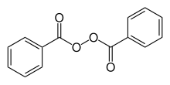
Figure 1: Chemical structure of Benzoyl peroxide²
Benzoyl peroxide used as a medication to treat mild to moderate acne. It has three-fold activity in treating acne. I.e. sebostatic, comedolytic, and inhibits growth of C. acnes. Its molecular formula is C₁₄H₁₀O₄. IUPAC name of benzoyl peroxide is benzoyl benzenecarboperoxoate³ (Fig 1).

MATERIALS AND METHODS
Instruments:
UV/Visible double beam spectrophotometer Systronic 2201. Standard cuvettes having 10mm of path length are used for analysis. Ultrasonicator (microclean-103) was used to sonicate the formulation sample. Drug sample was weighed by using electronic analytical balance (Shimadzu AY220).
Chemicals and reagents:
Active pharmaceutical ingredient of Benzoyl peroxide is gifted as a sample from Aadhaar Life Sciences Pvt. Ltd. Solapur. Marketed formulation of Benzoyl peroxide was procured from local pharmacy.

EXPERIMENTAL WORK
METHOD DEVELOPMENT
Preparation of standard stock solution of Benzoyl peroxide
10 mg of standard drug Benzoyl peroxide was accurately weighed and transferred into 10 ml volumetric flask and sufficient amount of methanol was added into it and sonicated for 15 minutes, finally volume was made up to the mark with the same solvent to make 1000 µg/ml stock solution. From this 1 ml was again diluted to 10 ml to get a concentration of 100 µg/ml of Benzoyl peroxide. From 100 µg/ml solution 5 ml was again diluted to 10 ml to get a concentration of 50 µg/ml.
Selection of Wavelength
To determine the wavelength for measurement, Benzoyl peroxide (50 µg/ml) solution was scanned in the range of 200-400nm against distilled water as blank. Wavelength of maximum absorption was determined for drug. Benzoyl peroxide showed maximum absorption at 245nm.
Assay of benzoyl peroxide gel
1gm of gel was accurately weighed and transferred into 10 ml volumetric flask and dissolve in 5 ml of acetone. This solution was sonicated for 15 minutes and final volume was made up to the mark with acetone. From this solution 1ml is transferred into 10 ml volumetric flask and diluted up to 10 ml with acetone. The absorbance of this solution was measured at 245 nm.

RESULT AND DISCUSSION
METHOD VALIDATION
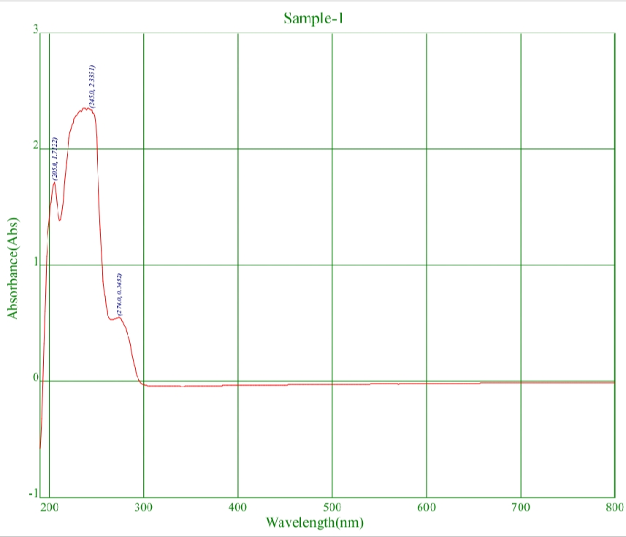
Figure 2: UV Visible Spectrophotometer Graph
The method was validated for several parameters like Linearity, Accuracy, Precision, Robustness, Limit of Detection (LOD), Limit of Quantification (LOQ) and Specificity of Benzoyl peroxide⁵⁻⁸.
- Linearity and Range
The linear relation between absorbance and concentration of drug was evaluated using three replicates over concentration range in 5-25 µg/ml by making the replicates (Table 1 & Fig 3).
Table 1: Results of Linearity
Sr. No | Concentration(µg/ml) | Absorbance
1 | 5 | 0.134
2 | 10 | 0.359
3 | 15 | 0.572
4 | 20 | 0.789
5 | 25 | 0.975

Figure 3: Calibration curve for Benzoyl peroxide
The wavelength for linearity was scanned at 245 nm. By taking five different concentrations for linearity the regression coefficient was found to be 0.9992 i.e. in limit of standard. Hence linearity parameter was found to be validated.

- Accuracy
Accuracy of the method was confirmed by recovery studies from marketed formulation at three different levels of standard i.e. 50%, 100%, 150% was done to confirm accuracy of the developed method. The amount of benzoyl peroxide is calculated at each level and percentage recoveries were calculated (Table 2).
Table 2: Results of Accuracy
Name of drug | Recovery levels | Concentration  (µg/ml) | Amount recovered | % Recovery with S.D.
Benzoyl peroxide | 50 % | 10 | 10.001 | 100.01±0.70
 | 100 % | 20 | 20.001 | 100.03±0.13
 | 150 % | 30 | 30.004 | 100.05±0.25

- Precision
Precision of the developed method expressed in terms of relative standard deviation of the absorbance. The solution was analyzed in 6 replicates for intra-day precision and in two successive days for inter-day precision. The % RSD value was found to be less than 2. Results confirmed that the precision of the method was found to be accepted. Precision results were given in table 3 and table 4 for intra and inter-day precision respectively.
Table 3: Results for Intra-day Precision
Sr. no. | Concentration (µg/ml) | Absorbance
1 | 10 | 0.538
2 | 10 | 0.539
3 | 10 | 0.537
4 | 10 | 0.539
5 | 10 | 0.537
6 | 10 | 0.539
S.D. |  | 0.000983
%RSD |  | 0.182693%

Table 4: Results for Inter-day precision
Sr. no. | Concentration (µg/ml) |  | Absorbance (Day1) |  | Absorbance (Day2)
1 |  | 10 |  | 0.538 |  | 0.537
2 |  | 10 |  | 0.539 |  | 0.538
3 |  | 10 |  | 0.537 |  | 0.539
4 |  | 10 |  | 0.539 |  | 0.538
5 |  | 10 |  | 0.537 |  | 0.537
6 |  | 10 |  | 0.539 |  | 0.539
S.D. |  |  |  | 0.000983 |  | 0.000894
%RSD |  |  |  | 0.182693% |  | 0.16625%

For Intra-day and inter-day precision relative standard deviation is in limit i.e. less than 2% hence parameter is validated.
- Robustness
Robustness is a measure of its capacity to remain unaffected by small, but deliberate variations in method parameters and provides an indication of its reliability during normal usage. Robustness was carried out on two different instruments and also carried out by using two different analysts (Table 5).

Table 5: Results for robustness
Wavelength | 245nm | 250nm
Concentration | 12µg/ml | 12µg/ml
Absorbance | 0.612 | 0.613
 | 0.613 | 0.612
 | 0.611 | 0.611
 | 0.613 | 0.612
 | 0.612 | 0.611
 | 0.614 | 0.613
Average | 0.613 | 0.612
S.D. | 0.0011 | 0.00089
% RSD | 0.179445 | 0.145425

By change in concentration and wavelengths i.e. 245nm and 250nm % RSD is less than 2% i.e. within the range. So parameter was validated
5. Ruggedness
The degree of reproducibility of test results of same sample within different laboratories and different analyst under same condition with same concentration.
Table 6: Results for ruggedness
Concentration | Analyst 1 | Analyst 2
15(µg/ml) | 0.764 | 0.765
 | 0.762 | 0.764
 | 0.765 | 0.766
 | 0.764 | 0.763
 | 0.766 | 0.765
 | 0.765 | 0.762

By change in analyst and laboratory, there is no effect on absorbance with same conditions (Table 6). Hence, parameter was validated.
6. Limit of detection (LOD)
Limit of detection of an individual analytical procedure is the lowest amount of analyte in the sample which can be detected but not necessarily quantitated as an exact value. LOD was found to be 0.862.
7. Limit of quantitation (LOQ)
Limit of quantitation of an individual analytical procedure is the lowest amount of an analyte in the sample which can be quantified as an exact value. LOQ was found to be 2.612.

CONCLUSION
The proposed UV spectroscopic method is found to be accurate, precise, stable, linear, specific, and simple for quantitative estimation of benzoyl peroxide in bulk and pharmaceutical dosage form. Hence the present UV spectroscopic method is suitable for routine assay of benzoyl peroxide in bulk and pharmaceutical formulations.

ACKNOWLEDGEMMENT
The authors are thankful to the principal and the management, DSTS Mandal’s College of Pharmacy Solapur, for providing the necessary facilities for research.
REFERENCES
- Wankhade RA, Bhalerao SB et al.Analysis of erythromycin and benzoyl peroxide incombined dosage form by UV-Visible shectrophotometry. Int J Pharm Pharm Sci., 2012; 4(4): 527-531
- https://www.drugbank.ca/drugs/DB09096.
- Kraingkrai PK, Kate GP. A rapid and sensitive spectrophotometric method for the determination of benzoyl peroxide in wheat flour samples. J of Food and Drug Analysis., 2015; 23(4): 652-659.
- Barange H, Ashar S and Sheikh U. Development of analytical method for simultenious estimation of Adapalene and Benzoyl peroxide in gel formulation by RP-HPLC. Global J of pharmacy and pharmaceutical sciences., 2018; 4(3): 555639.
- Tanner PT, Wong AY. Spectrophotometric determination of hydrogen peroxide in rainwater. Analytica Chimica Acta., 1998; 370(3): 279-287.
- Gupta A, Gulati M and Pandey N. A validated UV spectrophotometric methodfor simultaneous estimation of tretinoin and benzoyl peroxide in bulk and semisolid dosage form. Rasayan J. Chem.,2009; 3(2): 649-654.
- Sam-ang S, Kate G. A green analytical method for benzoyl peroxide determination by a sequential injection spectrophotometry using natural reagent extract from pumpkin. Talanta., 2017; 171: 236-241.
- ICH, Q2 (R1) validation of analytical procedures: text and methodology, International conference on harmonization; Nov.1996.

